Assignment 1

1.Explain the 10 function of Numpy

Python NumPy Operations

ndim:
import numpy as np
a = np.array([(1,2,3),(4,5,6)])
print(a.ndim)

itemsize:
import numpy as np
a = np.array([(1,2,3)])
print(a.itemsize)

dtype:
import numpy as np
a = np.array([(1,2,3)])
print(a.dtype)

reshape:
import numpy as np
a = np.array([(8,9,10),(11,12,13)])
print(a)
a=a.reshape(3,2)
print(a)

slicing:
import numpy as np
a=np.array([(1,2,3,4),(3,4,5,6)])
print(a[0,2])

max/ min
import numpy as np
a= np.array([1,2,3])
print(a.min())
print(a.max())
print(a.sum())

Square Root & Standard Deviation
import numpy as np
a=np.array([(1,2,3),(3,4,5,)])
print(np.sqrt(a))
print(np.std(a))

Addition Operation
import numpy as np
x= np.array([(1,2,3),(3,4,5)])
y= np.array([(1,2,3),(3,4,5)])
print(x+y)

linspace
import numpy as np
a=np.linspace(1,3,10)
print(a)

Vertical & Horizontal Stacking
import numpy as np
x= np.array([(1,2,3),(3,4,5)])
y= np.array([(1,2,3),(3,4,5)])
print(np.vstack((x,y)))
print(np.hstack((x,y)))

ravel
import numpy as np
x= np.array([(1,2,3),(3,4,5)])
print(x.ravel())

2.Explain concept of Data frame in ML and write 10 commands used in ML from Pandas

DataFrame is two-dimensional, size-mutable, heterogeneous tabular data structure with labeled rows and columns ( axes ). Can be thought of a dictionary-like container to store python Series objects.

pandas.DataFrame
import pandas
DataFrame = pandas.DataFrame({"A" : [1, 3, 4], "B": [5, 9, 12]})
print(DataFrame)

Read From and Write to Excel or CSV in pandas
DataFrame = DataFrame.read_excel("example.xlsx")
DataFrame = DataFrame.read_csv("example.csv")
DataFrame.to_excel("full_path_of_the_destination_folder/filename.xlsx")

Get the Mean, Median, and Mode
DataFrame.mean()

DataFrame.transform
DataFrame = DataFrame.transform(lambda y: y*3)
print(DataFrame)

DataFrame.isnull
DataFrame.isnull()

Dataframe.info
DataFrame.info()

DataFrame.describe
DataFrame.describe()

DataFrame.replace
DataFrame.replace([invalid_1, invalid_2], numpy.nan, inplace=True)
print(DataFrame)

DataFrame.fillna
DataFrame.fillna(df.mean(), inplace = True)
print(DataFrame)

DataFrame.dropna
DataFrame.dropna(inplace = True)
print(DataFrame)

3.Explain command dataset splitting in python.

If you were to split your dataset with 3 classes of equal numbers of instances as 2/3 for training and 1/3 for testing, your newly separated datasets would have zero label crossover. That's obviously a problem when trying to learn features to predict class labels. Thankfully, the train_test_split module automatically shuffles data first by default (you can override this by setting the shuffle parameter to False).
To do so, both the feature and target vectors (X and y) must be passed to the module. You should set a random_state for reproducibility. Either train_size or test_size needs to be set, but both are not necessary. If you do explicitly set both, they must add up to 1.

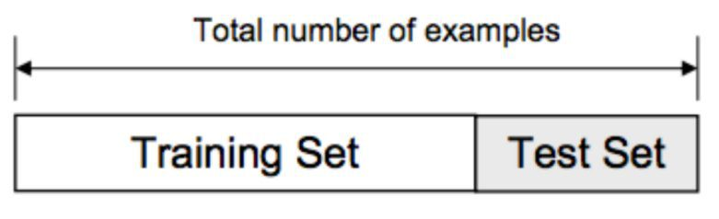

from sklearn.model_selection import train_test_split

X_train, X_test, y_train, y_test = train_test_split(X, y, train_size=0.67, random_state=42)

print(f"Train labels:\n{y_train}")
print(f"Test labels:\n{y_test}")

4. Write the command for model creation in linear regression

Step 1: Importing libraries
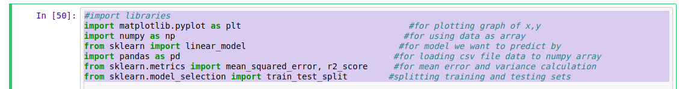
Step 2: Loading dataset
Step 3: Split to independent and dependent variables
Step 4: Splitting data into training and testing data
Step 5: Choosing the Model
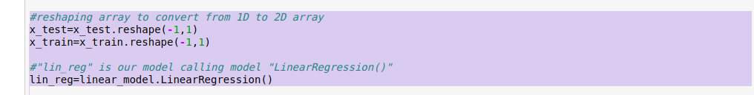
Step 6: Fit our model
Step 7: Predict the output
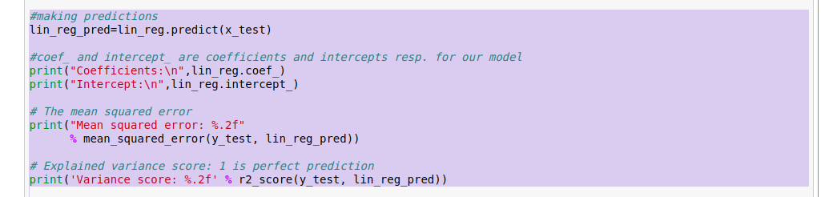
Step 8: Plot the graph
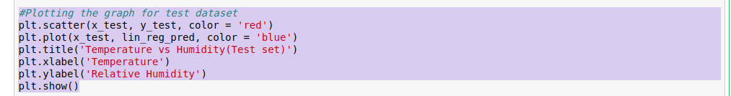

6.What is model.fit() and model.predict()?

Model fitting is the measure of how well a machine learning model generalizes data similar to that with which it was trained. A good model fit refers to a model that accurately approximates the output when it is provided with unseen inputs.
Python predict() function enables us to predict the labels of the data values on the basis of the trained model. The predict() function accepts only a single argument which is usually the data to be tested.

7. What are commands used for Data preprocessing?

Handling of Missing Data
# handling the missing data and replace missing values with nan from numpy and replace with mean of all the other values

imputer = SimpleImputer(missing_values=np.nan, strategy='mean')
imputer = imputer.fit(X[:, 1:])
X[:, 1:] = imputer.transform(X[:, 1:])

Handling of Categorical Data
# encode categorical data
from sklearn.preprocessing import LabelEncoder, OneHotEncoder
labelencoder_X = LabelEncoder()
X[:, 0] = labelencoder_X.fit_transform(X[:, 0])
onehotencoder = OneHotEncoder(categorical_features=[0])
X = onehotencoder.fit_transform(X).toarray()
labelencoder_Y = LabelEncoder()
Y = labelencoder_Y.fit_transform(Y)

Feature Scaling
sc_X = StandardScaler()
X_train = sc_X.fit_transform(X_train)
X_test = sc_X.transform(X_test)

8.Explain any pre-trained model and how it is useful in transfer learning

